www.edpuzzle.com

- Search for a video from ANY of these sources!
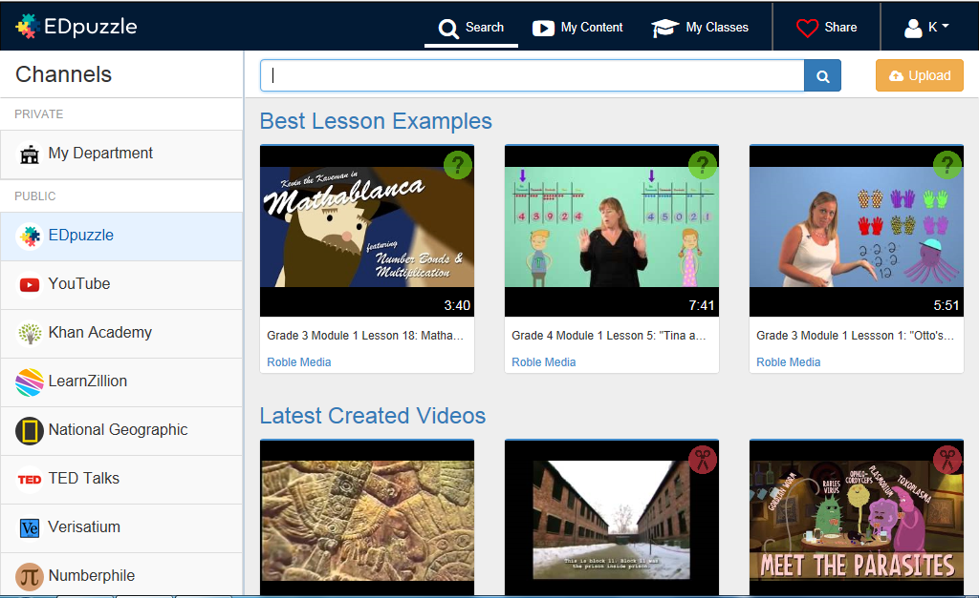
- You can crop the video down to just the minutes you want to show, record your voice over the entire video, record audio notes periodically throughout the video, or add written quiz questions throughout the video!
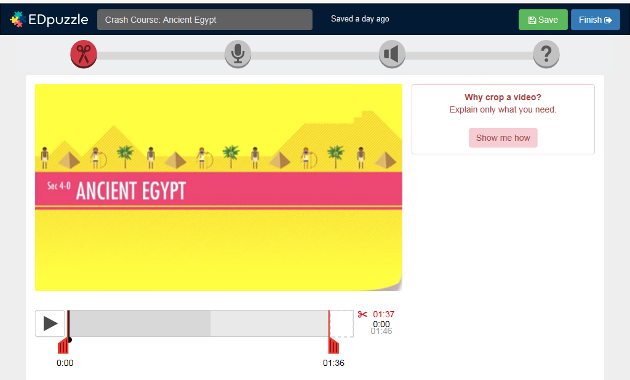
Add open ended, multiple choice and true/false questions. Also add written notes!
Add your own audio notes to the video
Record your own audio track for the video
Crop

- Each time you click to work with a specific tool, a “Show Me How” box will pop up. If you click on it, a short tutorial video will walk you through the process.
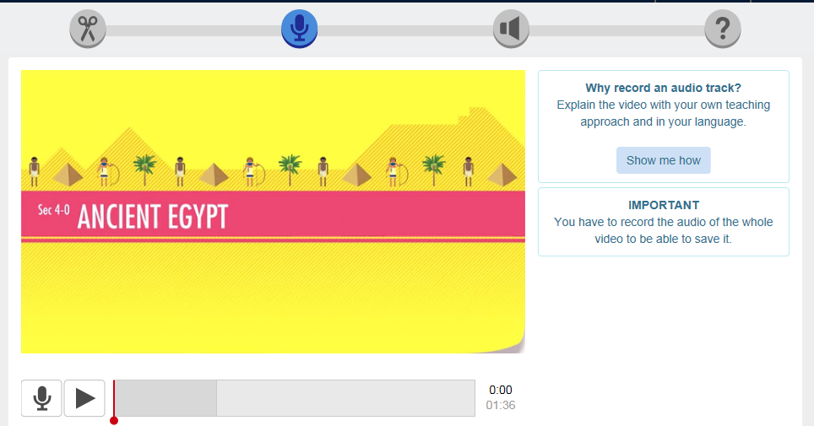
- Make sure you save.

- You have 3 choices when you want to share your video, Google Classroom, an EDpuzzle class or an Embed Code/URL.

Click on My Classes at the top of the page.
Choose how you want to share it, Google Classroom or creating an EDpuzzle class.
Import your Google Classroom
Create an EDpuzzle class
If you have classes in Google Classroom, then you can import them and then post/assign the video to the class of your choice. If you don’t have a Google Classroom, then I suggest creating an EDpuzzle class. It is very easy and similar to signing up for Remind. You simply give students the class code to type in when they go to EDpuzzle on the internet or via the FREE app.
To get the URL or Embed code, you click on the ASSIGN/SHARE button
and then click the SHARE WITH ANYONE button

You can copy and paste the link or embed code onto ITS Learning, your webpage etc.

*NOTE: If you can’t get the SHARE WITH ANYONE button to come up, then first share the video with one of your EDpuzzle or Google Classes. The next time you try to share it, the SHARE WITH ANYONE button should appear.

HELPFUL TIPS:
-You can upload your own videos.
-You can share videos with other teachers.
-The free EDpuzzle App allows students to view your videos on iPads, iPhones and other devices.
-There are multiple EDpuzzle tutorials and FAQ videos to watch on YouTube.
-If you like a video that you find, but don’t have time to edit it just click the COPY button and it will save it to your My Content page.
