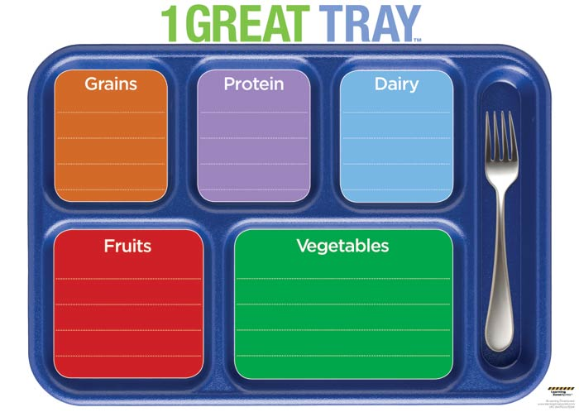

Fiction (3)

Nonfiction (2)

Folklore

Drama

Poetry

**Tray O’ Genres**

Fill in each spot on the tray with 1,2 or 3 matching books. Below each book, write the specific type of genre the book represents.